1  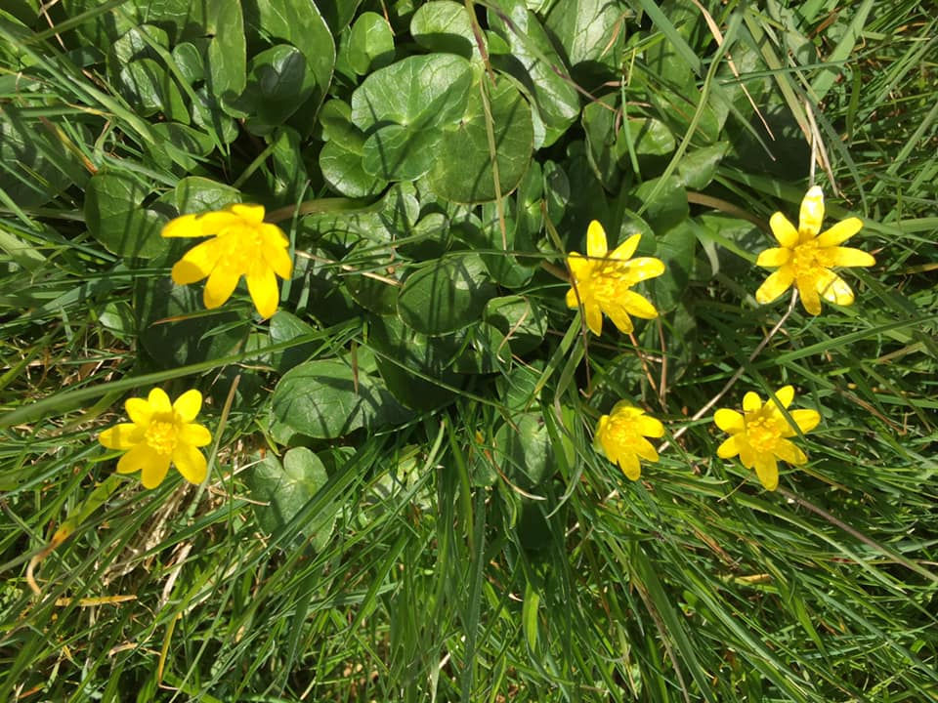  Can you use your maths eyes? What do you see? Can you take a photo in your house or garden and tell me what you see with your maths eyes? | 2  Can you go on a shape hunt around your house and/or garden? What shapes can you find? Can you describe the shape using their properties e.g. It has 4 straight equal sides and 4 corners. | 3  With help can you make tricky words cards or write them on post it notes and play snap.  Tricky words:  I, the, no, go, to, into, my, me, she, he, we, be, was, you, are | 4  Can you make a game of skittles from objects in your home such a bottles, tins or toilet rolls? Have a go at rolling a ball and see how many you can knock down. Can you keep score using a tally and add together your scores? | 5  What is your favourite story book? Can you draw a picture and write a sentence about your favourite story? | 6  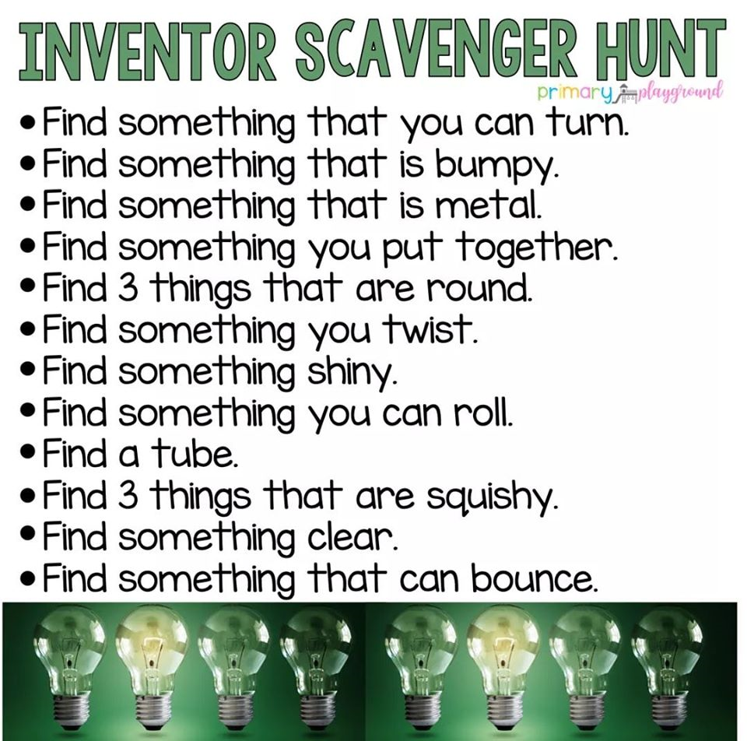
7  If you have a garden or go on a walk can you go on a minibeast hunt? What can you find? Maybe you could take some photos or draw a picture of what you found. How many different minibeasts did you find? | 8  Can you do some baking with an adult? What ingredients do you need? Can you help to use the weighing scales? Take a photo to share. | 9  Can you practice some animal yoga poses? Can you curl into a ball like a snail, stand up tall like a giraffe, balance on one leg like a flamingo, sit on your bottom, bend knees and bring the soles of your feet together like a butterfly? If you have the internet you could follow Cosmic kids yoga on You Tube for some ideas. | 10  With help can you write about what you have done today? Can you draw a picture too? | 11  Can you make a toy car wash? What do you need to clean the cars or other toys? | 12  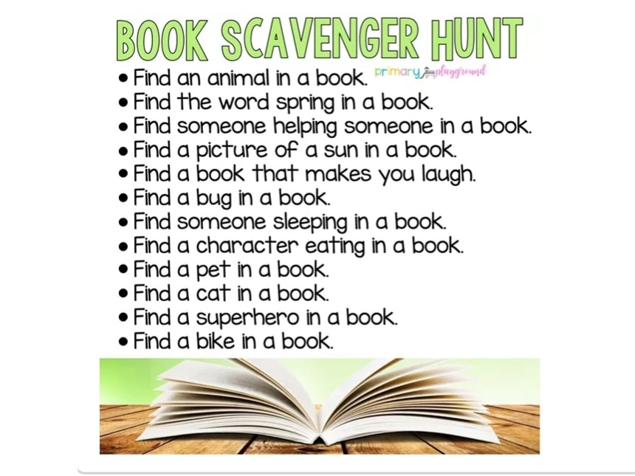
13  Can you practice your throwing and catching skills? How many times can you throw a ball in the air and catch it yourself? Can you throw and catch with a partner? | 14  Listen to some songs and make up a dance to your favourite song. | 15  With a grown-up play a listening game about a visit to a farm. “I went to the farm and I saw…” instead of saying the animal name split the word up into its three letter sounds. The other person has to identify the animal by blending the sounds together. Try: *cat, *dog, *pig, *cow, *hen, *sheep, *goat, *horse | 16  Read your favourite book with a grown up. Can you answer open-ended questions using why? , what? , when? where? and why? about the book: | 17  Look outside a window in your house, what do you see? Can you draw what you see? | 18  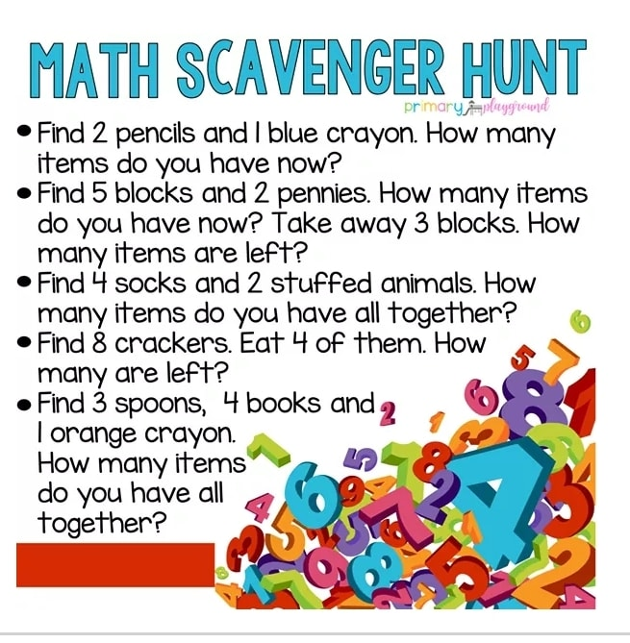
19  Write a letter or a card to a member of your family who you have not seen for a while- grandma, grandad, auntie, cousin etc | 20  Help your child to set up a pretend shop and make some price labels like 1p, 2p, 3p, 4p 5p 10p. Put the price labels on the items in your shop. Fill a purse with some coins and encourage your child to find the correct amount to buy the items. | 21  During time with your family, think about what you are grateful for, each share 1 thing you are grateful for. E.g I am grateful for my garden.  What are you most looking forward to once lockdown is over? | 22  Can you make play dough or slime? | 23  Can you practice doing buttons? Maybe you could dress a teddy in your school shirt and do their buttons up. | 24  Can you have a tea party with your teddies/toys? How many have come to the party? Can you make sure you share the food out equally?
25  Think about the story Goldilocks and the three bears which we have read in school. Can you make up your own ending? Maybe you could act this out with family members and video it or write it down. | 26  When you have a bath can you find some items and see if they float or sink. | 27  Make a den inside or outside? What could you use? (blankets, sheets) How will it stay up? What will you do in your den? | 28  Can you find a stick or another long object? Use it to find things that are longer, shorter and the same length. | 29  Turn a cardboard box into something extraordinary. | 30  Help your child to blend and segment some simple words and write them down, e.g. pan, sit, mat, pig. Can they make a simple sentence?

