1 Geography: The World’s Your Oyster!  Can you list a country for every letter of the alphabet?  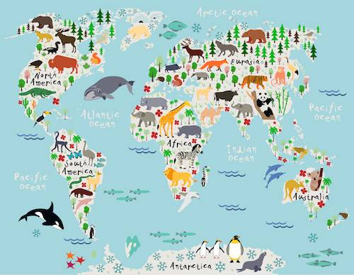  Find out what continent the country is on, how many countries are on the same continent?  https://www.kids-world-travel-guide.com/ | 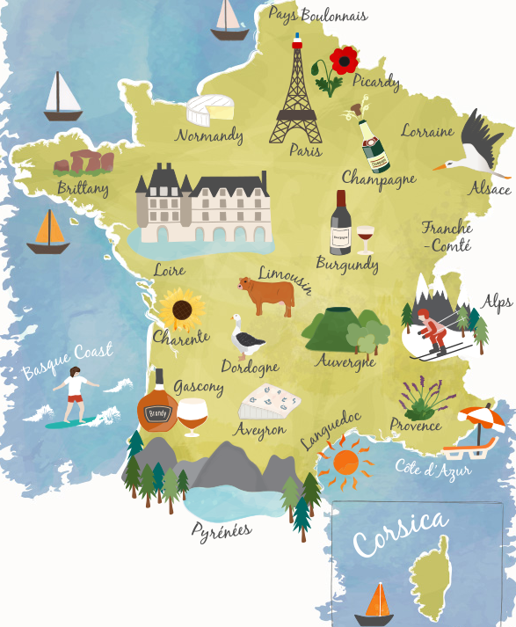  2 Geography: The World’s Your Oyster!  From your list, pick a country and research it.  Can you find photographs of human (man-made) and physical (natural) features?  Draw the flag, write or say a phrase in the language/s of the country, draw an infographic map (like the one shown) of the country, Find the capital city, research the nations favourite dish! The list is endless! | 3 Geography:  Famous Rivers & waterfalls!  Research rivers and waterfalls around the world, how long are they? Where is the source? Where is the river mouth? What sea does it flow into? Who or what lives around them and in them? You could also extend this to oceans – research the world’s oceans and tiny islands…  What and where is Micronesia? Find out! | 4 English:  Collective nouns!  A collective noun is a noun used to refer to a group of things.  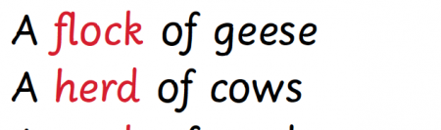  Find collective nouns for groups of animals or groups of people. You can create a quiz to share with your family or email it to school! | 5 English: Idioms!  Find as many idioms as you can and write the meanings.  You could draw a picture to help the explanation. Don’t forget to share them on the ks2 email! | 6 English: Reading Rocks!  Build a reading den!  Find somewhere cosy, snuggle up and read your favourite book!
7 English: Reading rocks!  Enjoy reading a book, website or even recipe of your choice. Keep a reading journal in your home reading record and note down your favourite authors, parts of the book, characters, words, etc. | 8 English: Reading Rocks!  Read out loud to someone. Remember to read with expression. | 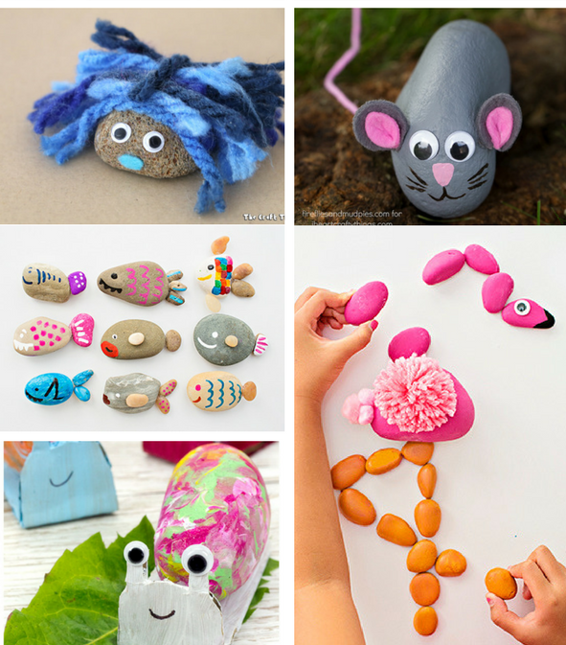  9 Art & D&T: No Pet – No problem! Create your own pebble pet – decorate a rock or pebble to look like an animal. | 10 English: Meet the Parents… Create some questions to ask your parents. What did like doing at school? What was in fashion when they were at school? What games did they play? Can they show you? | 11 History, Art, D&T: Create your own Anglo-Saxon settlement.  Look at:  https://www.bbc.co.uk/bitesize/clips/znjqxnb  for information about Anglo Saxon life – Can you create your own Anglo-Saxon mini settlement? | 12 History: Anglo-Saxon England: What did they do for us?  Names of some towns we have today come from the Anglo-Saxons. Visit the website and read the information about place names. How many places can you find with Anglo-Saxon place names? Can you find them on a map? Have you or your parents visited any of the places?  http://history.parkfieldprimary.com/anglo-saxons/anglo-saxon-place-names
13 Geography: Draw a map of your local area (or home) and highlight interesting landmarks. Don’t forget to create a key! | 14 Science: Physics  Space Research – Visit NASA’s website and find about life in space – watch an astronaut’s daily routine in space or find out what the Hubble Telescope viewed on the day you were born! https://www.nasa.gov/stem-at-home-for-students-5-8.html | 15 Art: Draw a view. Look out of your window and draw what you see. | 16 Art: Hold a photo session. Use a camera or a mobile phone to take some snaps. What will you photograph? Your pets or toys perhaps? | 17 Science: Biology  Start a nature diary. Look out of the window each day and keep note of what you see. Birds, flowers, changes in the weather, what else? | 18 Science: Biology  Take part in the RSPB’s Big Garden Bird Watch! No garden – no problem! – look on the website and you can play videos about different birds and even hear their birdsongs! https://www.rspb.org.uk/get-involved/activities/birdwatch/
19 Treat others as you would like to be treated yourself!  Do something kind for someone. Can you pay them a compliment, make them something or help them with a task? | 20 List making!  Write a list of things that make you happy, things you’re grateful for or things you are good at. | 21 English: Can you create a story bag? Find a bag and collect items to go in it that relate to a well-known story. If you can’t find an item, you could draw a picture to include. | 22 Art & Craft:  Junk modelling! Collect and recycle materials such as yoghurt pots, toilet rolls and boxes and see what you can create with them. | 23 PE Keep moving! Make up a dance routine to your favourite song. | 24 Music & Science! Write a song or rap about your favourite subject. You could watch the planets song for inspiration!  https://youtu.be/PCxjuDePdCI
25 Spelling games! Have a look the spelling games. https://www.topmarks.co.uk/english-games/7-11-years/spelling-and-grammar | 26 Read around the world! Look at and complete the reading challenge! https://literacytrust.org.uk/resources/reading-miles-global-challenge/ | 27 English – Poetry-Beautiful Ambition – Be inspired by your favourite footballers! https://plprimarystars.com/resources/premier-league-writing-stars-poetry-challenge | 28 Puppet Making! Look on the following website get creative! https://www.handmadecharlotte.com/diy-flamingo-marionette/ | 29 English: Future self: Write a letter to your future self. Describe what you like doing, a photograph or self-portrait, what you want to do in the future, how you feel in the current situation, what advise you would give to yourself in the future? | 30 Film Critic! Watch a film and write a review. What did you like? What genre is the film? Is it based on a book? What are the similarities and differences to the book?

