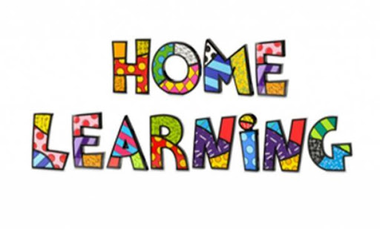
Marshside Primary School
Treat others as you would expect to be treated yourself.

Home learning week commencing Monday 29th June 2020

Dear Parents and Carers,

We have really appreciated the feedback on the Home Learning Packs during the last 3 weeks. Just a reminder if you need paper copies then please contact school. Teachers have attempted to contact all families not accessing school in the last 2 weeks. If you have not received this contact then please do not hesitate to give us a ring.

Please note that you do not need log in details for the school’s website. If you need any further advice or support please do not hesitate to contact school.

Thank you for sending in examples of the work that your children are doing. Staff love seeing this. We have uploaded some of the work completed in school onto the website. Click here. Also if you find a website that is really useful, please share.

Online English Lessons.
Using Oak Academy and supported with other online learning platforms.

EYFS | Traditional Tales: Hansel and Gretel  Oak Academy – 5 English lessons – 1 each day  Select: Hansel and Gretel  Phonics: l, e, j, h, r  BBC bitesize l BBC bitesize e BBC bitesize j BBC bitesize h BBC bitesize r
Y1 | Character description: Saint George and the Dragon  Oak Academy – 5 English lessons – 1 each day  Select: Genre Focus Character Description  Phonics: ow (as in rainbow), oa, o-e  BBC bitesize oa BBC bitesize tricky words
Y2 | Recount: The Firework Maker’s Daughter  Oak Academy – 5 English lessons – 1 each day  Select: Genre Focus Recount  SPAG: different sentence types  BBC bitesize How to write command sentences BBC bitesize How to write questions  BBC bitesize How to write exclamations  Phonics Play Interactive phonic games Planetary Plurals  Username: march20 Password: home
Y3 | Character Descriptions:  Oak Academy – 10 English lessons – 1 each day- lessons 1-5  Select: Genre Focus Character Descriptions  SPAG: Conjunctions  BBC bitesize What are subordinating conjunctions? BBC bitesize What are coordinating conjunctions?
Y4 | Non-Chronological Report: The Sneagleonkey  Oak Academy – 5 English lessons – 1 each day  Select: Genre Focus Non-Chronological reports  SPAG: Conjunctions  BBC bitesize What are subordinating conjunctions? BBC bitesize What are coordinating conjunctions?
Y5 | Diary: Diary of a Wimpy Kid  Oak Academy – 5 English lessons – 1 each day  Select: Genre Focus Diary  SPAG: Formality  BBC bitesize Writing a diary entry BBC bitesize How to write for different audiences
Y6 | Setting Description:  Oak Academy – 5 English lessons – 1 each day  Select: Genre focus Setting description  SPAG: Figurative language  BBC bitesize Using setting descriptions

Book Trust: Lots of lovely interactive books to share.

Online maths lessons from White Rose Maths

 |  | Term Week
EYFS | Taking Away | Summer Term Week 10 | Pick the worksheet for your year group and lesson
Y1 | Place Value | Summer Term Week 10
Y2 | Measure | Summer Term Week 10
Y3 | Angles, Shape and Time | Summer Term Week 8
Y4 | Money and Statistics | Summer Term Week 10
Y5 | Decimals and Geometry | Summer Term Week 10
Y6 | Measures and Ratio | Summer Term Week 10

My Maths activities are still being set by teachers, so this offers additional support if required.
Some parents have had problems printing the White Rose Maths Sheets – you may need to adjust the SCALE from DEFAULT to FIT TO PAGE.

Foundation Subject.
This week we are covering a number of different subjects. Please scroll down to the allocated section.

 | Topic
EYFS | Habitats | 5 lessons | BBC Bitesize Habitats and the environment
Y1 | Humanities – History – Explorers and Adventurers | 8 lessons | BBC Bitesize Neil Armstrong
Y2 | Humanities – The Shang Dynasty | 8 lessons | BBC Bitesize
Y3 | Humanities - The Norman Conquest | 5 lessons | BBC Bitesize
Y4 | Humanities – The Spanish Armada | 3 lessons | Primary Homework Helps  The School Run
Y5 | Humanities – Medieval Monarchs continued | 8 lessons | BBC Bitesize - 1066  The School Run – Henry VIII  Primary Homework Elizabeth I
Y6 | Humanities – WWll continued | 8 lessons | World War Two  Children of WW2

Next week.
Activities uploaded previously are still on the website and can continue to be accessed.

A final note….
Staff in school love to see what the children are up to, so please keep sending in the photos, if you can of any activities.
Can I remind you all that we have 2 emails for you to send any photos of work to us to share.
ks1@marshside.sefton.school ks2@marshside.sefton.school

Photos of work are uploaded onto the gallery page of the website.
Under Current Closure: Class Gallery.

Best wishes from everyone at Marshside.

